**City Block distance**

% Initialize a 100x100 matrix with zeros

A = zeros(100, 100);

% Define the circle parameters

Cx = 50; % X-coordinate of the circle center

Cy = 50; % Y-coordinate of the circle center

Radius = 20; % Radius of the circle

% Iterate through each pixel in the matrix

for i = 1:100

for j = 1:100

% Calculate the City Block distance from (i, j) to the center (Cx, Cy)

distance = abs(Cx - i) + abs(Cy - j);

% Check if the distance is less than or equal to the radius

if distance <= Radius

A(i, j) = 255; % Set the pixel value to 255 (white)

end

end

end

% Display the resulting image

imshow(A, []);

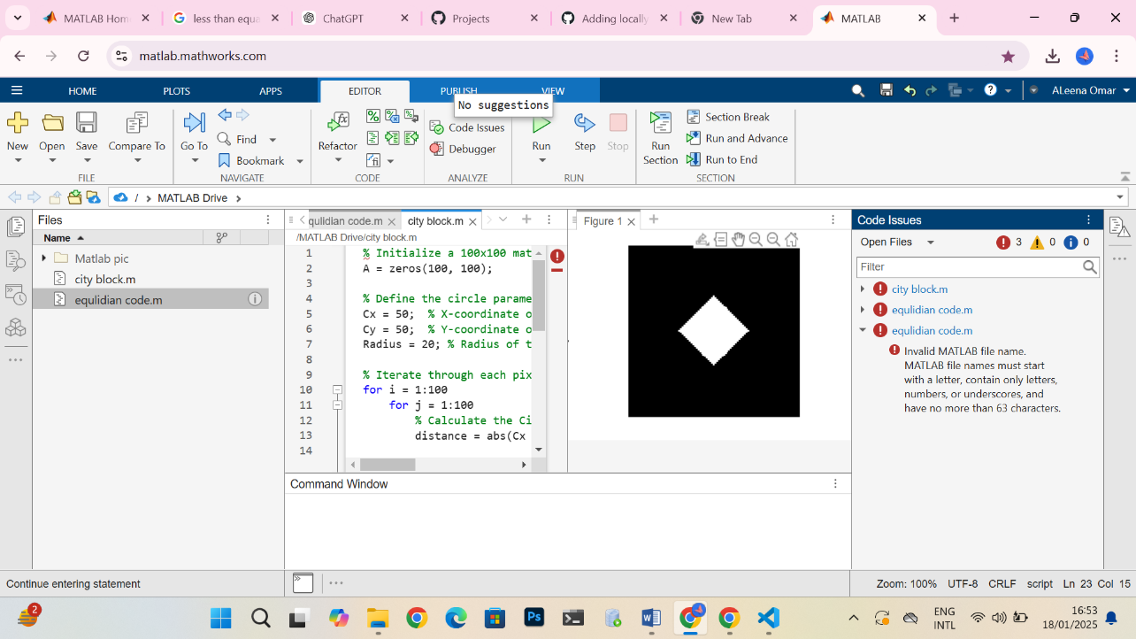

**Chess board**

% Initialize a 100x100 matrix with zeros

A = zeros(100, 100);

% Define the circle parameters

Cx = 50; % X-coordinate of the circle center

Cy = 50; % Y-coordinate of the circle center

Radius = 20; % Radius of the circle

% Iterate through each pixel in the matrix

for i = 1:100

for j = 1:100

% Calculate the Chessboard distance from (i, j) to the center (Cx, Cy)

distance = max(abs(Cx - i), abs(Cy - j));

% Check if the distance is less than or equal to the radius

if distance <= Radius

A(i, j) = 255; % Set the pixel value to 255 (white)

end

end

end

% Display the resulting image

imshow(A, []);

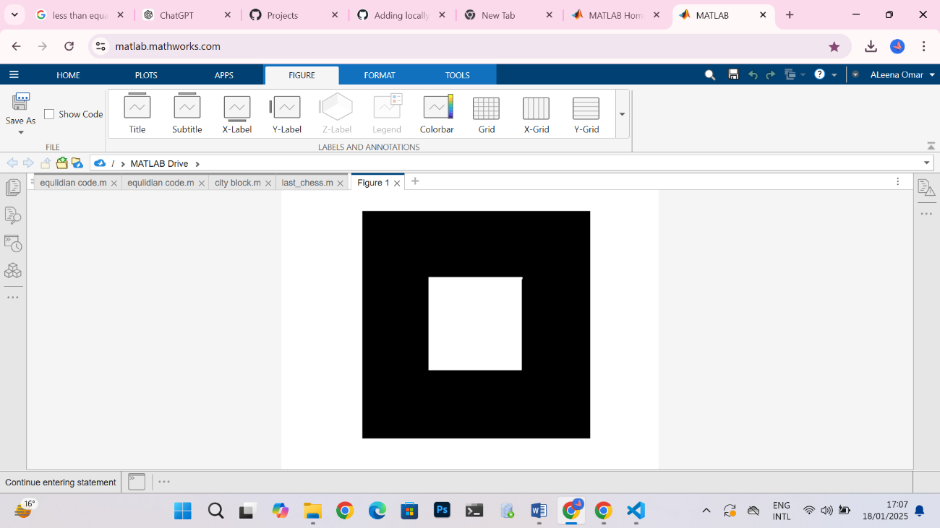

**Equalidian distance**

A = zeros(100, 100); % Initialize a 100x100 matrix with zeros

Cx = 50; % X-coordinate of the circle center

Cy = 50; % Y-coordinate of the circle center

Radius = 20; % Radius of the circle

for i = 1:100

for j = 1:100

% Calculate the Euclidean distance from (i, j) to the center (Cx, Cy)

distance = sqrt((Cx - i)^2 + (Cy - j)^2);

% If the distance is less than or equal to the radius, set pixel value to 255

if distance <= Radius

A(i, j) = 255;

end

end

end

% Display the matrix as an image

imshow(A, []);

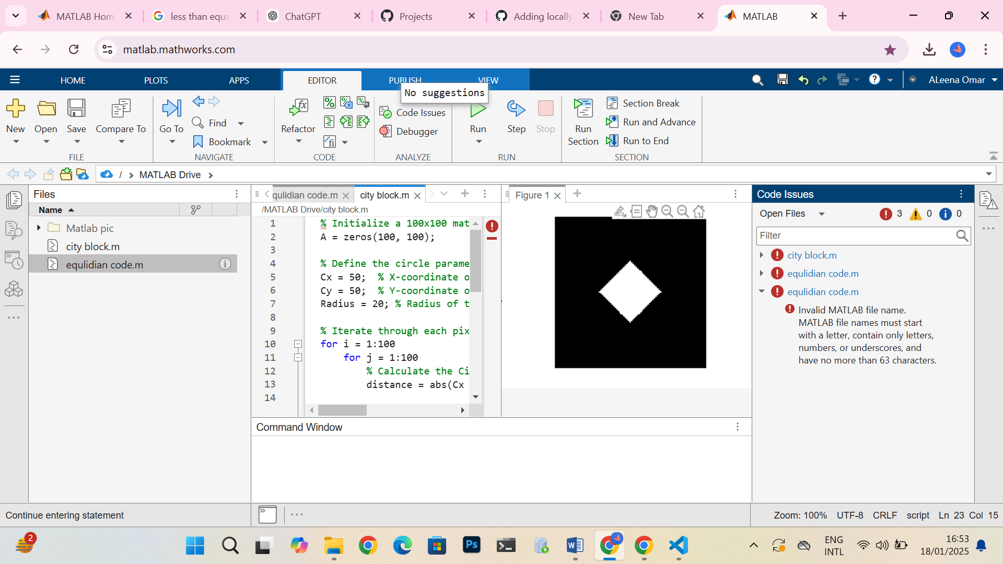

A = zeros(100, 100); % Initialize a 100x100 matrix with zeros

Cx = 50; % X-coordinate of the circle center

Cy = 50; % Y-coordinate of the circle center

Radius = 20; % Radius of the circle

for i = 1:100

for j = 1:100

% Calculate the Euclidean distance from (i, j) to the center (Cx, Cy)

distance = sqrt((Cx - i)^2 + (Cy - j)^2);

% If the distance is less than or equal to the radius, set pixel value to 255

if distance <= Radius

A(i, j) = 255;

end

end

end

% Display the matrix as an image

imshow(A, []);